**Integrating Geographic Information Systems and Drone Technology for Drainage System Mapping: A Case Study of Ayeduase Area**

**Introduction**  
Climate change remains a pressing global concern, provoking heightened distress and advocacy from renowned activists and international organizations like Greta Thunberg, the United Nations (UN), Climate Advocacy International (CAI), and the Green Africa Youth Organization (GAYO). The impact of intensified and prolonged rainfall—a manifestation of the changing weather patterns—ranges from erosion and significant flooding to extensive destruction, all detrimental to the holistic well-being of the impacted populations. This escalation in climatic extremities has exposed the inadequacies of drainage systems initially designed without consideration for such alterations in climate, leading to overflows and consequent flooding of infrastructures and residences in regions previously regarded as safe from flooding. Addressing these climatic exigencies necessitates the enhancement and maintenance of efficient drainage systems, epitomized as essential environmental assets in averting calamitous meteorological events and maintaining ecological equilibrium. The Ayeduase community, marked by its significant student population, stands as a crucial area where the degradation of such assets due to negligence is particularly discernible. In light of the pivotal need for effective drainage systems, especially in areas like Ayeduase with its notable aging and faulty infrastructures (Leslie et al., 2016), there’s an evident research gap. Most of the current research on urban flooding thoroughly investigates the problems of urban pluvial flooding, but there is a conspicuous absence of detailed studies on the interactions between surface runoff and pipe flow within specific urban topographies like Ayeduase. A closer look at specific urban topographical features and their uniquely constructed channels is crucial to understanding the precise causes of floods in urban areas. These smaller and specific areas, including both their natural and artificial drainage systems, are often left underexamined in favor of broader, more general studies focusing on larger areas and natural water bodies like rivers and lakes. This study, understanding the need for specificity and detail, aims to bridge this research gap by mapping a part of the drainage system of the Ayeduase community to inform decisions. This will be done with the objectives of creating an inventory of the current drainage system, giving an overview of the system and its physical condition, and to map the drainage system, and making propositions on design based on findings. This project integrates Geographic Information Systems (GIS) and drone technology to proffer transformative methodologies in mapping and analyzing drainage systems in terrains like Ayeduase (ESRI, 2021; Dangermond, 2021; Seth Thompson, 2020). The use of GIS provides an unparalleled facility in the collection, analysis, and interpretation of geographical data, crucial for addressing issues like flood hazard mapping and drainage flow direction determination (Kraak & Ormeling, 2013; Chen, 2011). Additionally, the incorporation of drone technology, a cutting-edge advancement in photogrammetry, offers flexibility, cost-efficiency, and high-resolution data, overcoming the limitations of traditional aerial mapping techniques (Seth Thompson, 2020). With an increasing acknowledgment of the need to consider both constructed components and topographic elements of the drainage system among spatial data analysts, technologies like GIS and photogrammetry, alongside software like ArcGIS, QGIS, and Agisoft, become integral. They enable holistic mapping, analysis, and prediction of efficiency, resilience, and related challenges of drainage systems in the face of evolving climatic conditions (Wolf & Dewitt, 2000; Shawky et al., 2019; ESRI, 2017). By employing such advanced technologies, this study provides a more detailed insight into the current state of the Ayeduase local drainage system. It is poised to reveal potential areas requiring improvement or repair, ensuring the continued safety and resilience of the community, and addressing the identified gap by focusing on the unique characteristics and features of this specific urban terrain. In doing so, this research not only contributes to the field by offering specific insights and nuanced understandings of urban drainage systems but also plays a crucial role in informing future interventions and policy decisions aimed at enhancing urban resilience in the face of climate change.

**Method**

This study involved the use of two main disciplines in Geomatics Engineering, namely Photogrammetry and Geographic Information Systems, and inventory data collection as well. These approaches were employed to be able to achieve the aim of mapping the drainage system of the study area to inform decisions. In the process of achieving the aim set for this project, two objectives were set, the first was to make an inventory data of the current drainage system to give an overview of the system’s physical condition. The second objective was to make a series of maps of the drainage system and make propositions on the design of the system based on the findings. By asking questions like what are the locations, dimensions, and conditions of the culverts and the drains in the community, inventory data were collected at the study area which was further used in subsequent processes in the project, by diving into the cartographic characteristics of a drainage map, series of maps were generated to enhance further discussions that lead to making propositions for authorities to act on.

**Study Area**

Ayeduase is located between 6° 40' 4" N and 6° 40' 41" N, and 1° 33' 03" W and 1° 33' 50" W in the Oforikrom Municipality of Kumasi, Ghana. With an area of 98 Acres, the human population of Ayeduase is estimated to be 29,748 people, and the settlement is located at a height of 246 meters above sea level. The majority of land use in the Ayeduase community is a settlement that is largely populated by KNUST students. As a result, this neighborhood is home to the bulk of students and inhabitants. The terrain is undulating. A portion of Ayeduase is of interest in this project. As a result, a unique area of Ayeduase is picked, the drainage system is mapped, and the state of the area is disclosed for decision-making.

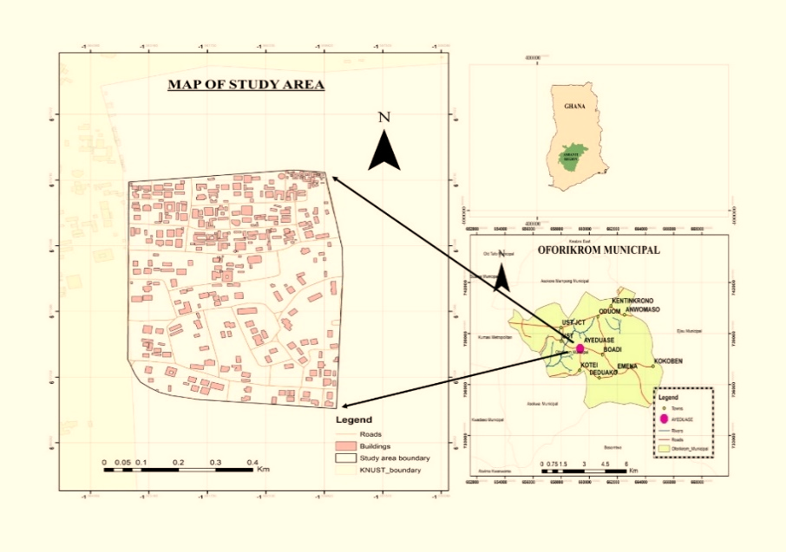

Figure 1. Map of the study area

**Research Approach**

In research projects, a structured and strategic approach becomes the guiding compass toward achieving predefined objectives. Such methodologies serve as the platform ensuring the seamless orchestration of endeavors, culminating in the realization of intended goals. Amid this orchestration, a combination of elements converges to shape the approach – data collection techniques, technical procedures, and research methods are chosen, materials meticulously curated, and resources thoughtfully marshaled. Additionally, the tapestry extends to encompass immersive fieldwork, pivotal interactions, and the distinct domain or subject of study that weaves through the fabric of the research journey. By following a similar methodical process, the aims and objectives were achieved. This voyage adhered to a parallel roadmap that had been painstakingly drawn up to help the participants deal with the challenges presented by the objectives they had agreed to. This project fits its course with the greater framework of project management principles by integrating research methods, resource allocation, and on-site interactions. These components combined to form the project's journey, which aimed at achieving goals with actions and aspirations with successful outcomes. The methodological process that was

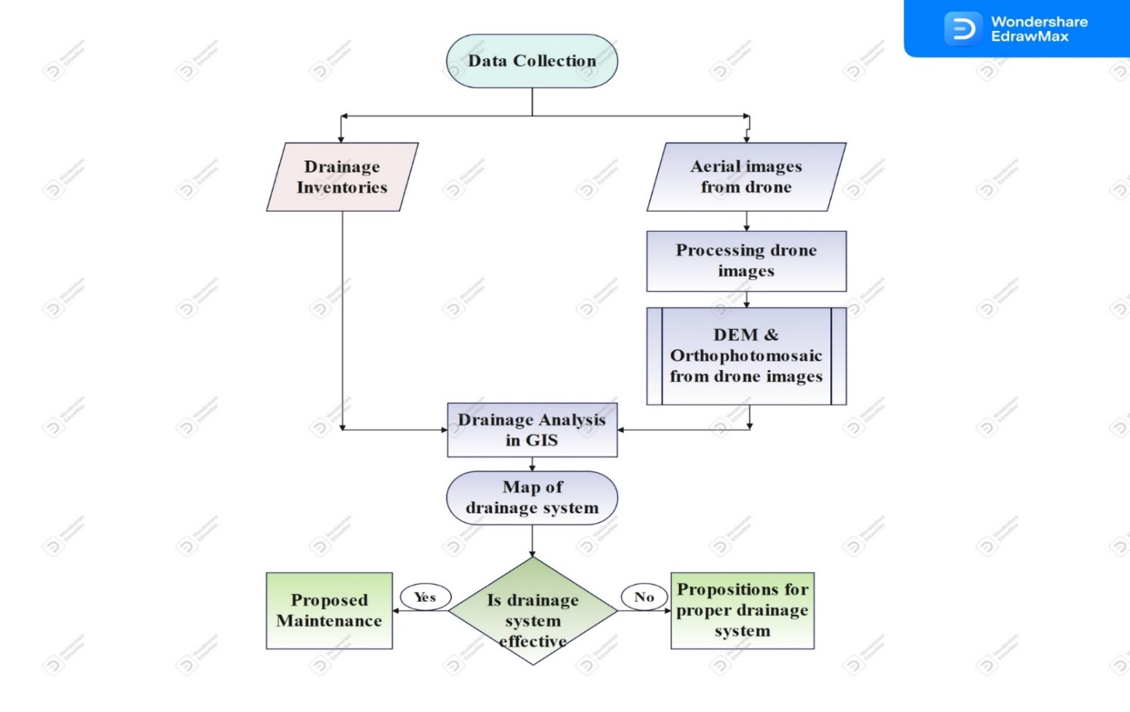

Figure 2. Methodology for mapping drainage system

**Data collection**

In this research, certain data were collected. These data are part of the project’s objectives that sought the smooth progress of the project and realization of the aim. As such, mapping the drainage system from this project’s perspective required data such as the drainage inventory of the study area and aerial photographs. These data were obtained and used for several processes as illustrated in subsequent topics.

**Inventory data**

Inventory data in simple terms means data on the types of the drains, depth of the drains, location of the drains, length of the drains, size of drains, culverts, and the conditions of the drains as well. The inventory data helped to know the location and condition of the drainages in the area and together with their respective conditions, provided the necessary data for discussion. These procedures helped to understand the occurrence and processes of water movement in the area. It helped determine whether the drains in the area are good enough to sustain any high flow of water dissipating through the drains and the measures that must be put in place to reduce the damage to structures around the drains and the area as a whole. However, to be able to determine these parameters for the project, measuring tapes and leveling staff was essential for the project. The measuring tapes and leveling instruments helped determine the depth and the length of the drains. Moreover, with the help of a mobile phone, pictures of the conditions of these drains and culverts were captured as well. GPS essentials were used to get the locations of the culverts. Conditions of the drains such as broken drains, clogged drains, fully or partially silted, etc. were recorded as the pictures were taken.

**Aerial photographs**

Aerial photographs, products of the photogrammetric technique, are photos that are taken above the surface of the ground by a camera mounted on a platform in the air, the platform being an aircraft, drone, balloon, etc. Aerial photographs of the study area were essential for this project, in the process of mapping the drainage system, an orthophoto mosaic, Digital Terrain Model, and Digital Elevation Models of the study area were required for drainage analysis using GIS. A Digital Elevation Model shows the elevation of the ground surface and features, it shows the topographic nature of the surface in context. A Digital Terrain Model gives the elevation of the terrain. In this study, the photographs were primarily obtained from a drone survey in the study area. A drone survey was undertaken in the study area, where a drone was flown at an appropriate altitude to obtain aerial photographs for further processing. Flying a drone had the benefit of choosing the appropriate altitude to affect resolution and it gave the research control over the scale.

**Ground controls**

Providing Ground Controls involves getting points whose positions are known in the object space reference coordinate system and whose image can be positively identified on the images or photographs (Agyemang et al., 2020). Specific points (four points) on the ground were chosen after the drone survey, these points were selected such that they were evenly spread (mostly on corners of the entire area captured), they were also made to be very clear on the image, they were permanent points as much as possible, these points were required to be found on adjacent images as well. To avoid any errors when selecting points, the points were selected after the orthophoto mosaic had been generated. They were marked and coordinated with a GPS instrument to serve as ground controls. GPS in static mode was placed on each of these points for a minimum of ten (10) minutes to collect data for processing to generate ground coordinates in an appropriate coordinate system. All GPS data related to this project were processed with Trimble Business Center (64-bit).

**Processing of aerial photos**

Once the various spatial and non-spatial data had been acquired, the next activity was to process and analyze the data. In this regard, Agisoft photoscan professional v1.2.6, a photogrammetric software developed by Agisoft LLC was used to process the images from the drone survey, creating a DEM or a DTM for the entire area captured by the survey. In general, a DEM is an umbrella term for any electronically accessible elevation datasets, such as Digital Terrain Models (DTMs) and Digital Surface Models (DSMs). It includes measures of the Earth’s terrain, in addition to natural and human-based objects above a certain datum. (Shawky et al., 2019). In the Agisoft photoscan professional software, different kinds of products could further be obtained from the aerial images, products such as a 3D model, orthophoto mosaic, etc. The DTM and orthophoto mosaic were then used in ArcMap 10.5, a GIS software fully developed by ESRI, for several drainage analyses.

**Analysis in ArcMap**

After aerial photographs have been processed in Agisoft Photoscan Professional and all the data needed are obtained, the next processes continue in ArcMap. Georeferencing is the process of assigning real-world coordinates to a map, photograph, or image. Georeferencing associates features on the image or photograph with real-world x and y coordinates. These coordinates are ground coordinates carefully obtained through a proper field survey with a GPS instrument. After the orthophoto mosaic was loaded in ArcMap, the ground controls whose coordinates had been obtained were used to georeference the image using the georeferencing tool. Digitizing in GIS is the process of converting geographic data either from a hardcopy or scanned image into vector data by tracing features. During the digitizing process, features from the traced map or image are captured as coordinates in either point, line, or polygon format. (ESRI, 2022). From the high-resolution georeferenced orthophoto mosaic, all features of interest were visible enough for digitizing. In ArcMap, with the help of the “editor” tool, the drainages in the study area were digitized from the georeferenced orthophoto mosaic forming a layer in ArcMap. A layer of road network in the study area was obtained with the help of ArcMap and that will also form another layer. The building layer was also obtained in ArcMap. Knowing the locations of buildings and overlaying the buildings layer with the topographic layer showed which buildings are in the natural channels of the study area and this provided information for discussion. Utilizing ArcMap tools, the contours of the study area were generated from the DTM obtained from the DEM data which was obtained from Agisoft Photoscan Professional. Contour lines depict elevations of places having equal elevation. This operation in ArcMap helped give a better understanding of the relationship between the drainage system and the topographic nature of the area. The topographic landform from the DTM revealed the natural channels of runoff in the area. All layers of roads, buildings, contours, and land use of the study area were added and bounded together with the drainage layers to create a drainage system map, all layers annotated in a legend, with grid lines, a north arrow, and all elements of a map needed to visualize the map for discussions.

**Results And Discussions**

This project intended to map the drainage system of a part of the Ayeduase community to inform the best decisions from it. Throughout the project, the main focus was on two main objectives: an inventory of the drainage system in the area and a map of the drainage system of the study area. This led to a series of field and remote activities that produced results that were necessary for the study's aims and objectives. A drainage inventory was acquired through several measurements during site visits for data collection. A combination of drone technology, which is an application of Photogrammetric knowledge was employed in obtaining high-resolution aerial images of the study area, Agisoft Photoscan, an image processing software was used in processing aerial images obtained from drone flight conducted over the study area. Following a workflow in Agisoft Photoscan software, products like 3D models and orthophoto mosaics were obtained. A Digital Terrain Model (DTM) was generated through the Dense Cloud Classification process in Agisoft (thus by classifying and separating dense cloud points between ground points and natural and man-made features above the ground). After all the image processing in Agisoft software, the results generated from each step along the processing workflow of the drone photographs were subjected to several processes in ArcGIS, processes including georeferencing the orthophoto mosaic acquired, digitizing all the features on the orthophoto mosaic, generating contours from the Digital Terrain Model (DTM), these processes led generating the final map. This section shows a chronological series of presentations on the results of the various processes undertaken in the project as well as discussions. Since the various processes affected the final output, the results of each activity or process are shown in detail. This chapter also includes a lot of analysis that has been made on the subsequent and final results that will be presented in this section, moreover, there are several discussions on the results as well.

**Drainage Inventory**

The drainage inventory concerning this project is a combination of data in different formats (images, texts). The inventory has data such as images of culverts in the study area, their type, their geographical locations (coordinates), and their dimensions in terms of length, breadth, depth, and number of outlets, their conditions were also recorded as either silted, blocked, silted and blocked, broken, clogged, clogged mid-way, okay or in good condition. The conditions were recorded as part of the inventory data to give an overview of the drainage system and its physical state as highlighted in the objectives of this project. Below are figures of the drainage inventory data obtained through measurements during site visits. Below is a table showing the inventory list on the culverts (See Table 1).

**Table 1. Culvert Inventory Data**

|  |  |  |  |  |  |  |  |
| --- | --- | --- | --- | --- | --- | --- | --- |
| ***Type*** | ***Outlet*** | ***Length(m)*** | ***Location*** | ***Condition*** | ***Description*** | ***Name*** | ***Size*** |
| Pipe Culvert | 2 | 11 | 221438.30mN, 211985.17mE | Good but silted | Behind Nana Adoma Hostel | Culvert 1 | 2m x 2m |
| Pipe Culvert | 1 | 14 | 221420.88mN, 211985.73mE | Good | Behind Nana Adoma Hostel Heading to Canam Hostel | Culvert 2 | 1.2m x 1.2m |
| Pipe Culvert & BC | 1 | 10 | 221585.18mN, 212554.51mE | Good | Kotei Road | Culvert 3 |  |
| Box Culvert | 1 | 3 | 221606.20mN, 212260.74mE | Broken | 85m from SDA Church | Culvert 4 | 1.5m x 1.8m |
| Pipe Culvert | 1 | 8 | 221472.74mN, 212095.77mE | Clogged | Behind White House Hostel | Culvert 5 | 2m x 2m |
| Pipe Culvert | 1 | 11 | 221456.46mN, 212097.77mE | Clogged midway | In front of Frontline Inn | Culvert 6 | 1m x 1m |
| Pipe Culvert | 1 | 4 | 221480.82mN, 212429.92mE | Good | Behind First Love Church | Culvert 7 | 0.95m x 0.95m |

**Physical State of drains and culverts**

The pursuit of drainage inventory data required a meticulous on-site physical inspection of all the drains and culverts within the study area boundaries to discern their physical states. Several images were captured within the study area showcasing the various states of the culverts. In the context of field observations, several key observables and their respective concerns were noted. Notably, the area lacks any underground or pipe drain; only the surface type of artificial drains in the form of open drains were present in the study area, pointing to a reliance on surface drainage systems as opposed to subsurface ones. Prominently, large channels, approximately 1.5m in width and 2.5m in depth were evident in specific parts of the area, seemingly created by erosion. Observations from the site and accounts from some residents suggest that new constructions have obstructed allowances for surface water drainage. The resulting runoff, gaining momentum as it slopes downward, has formed a substantial gully, running about 10m in length along the channel. Moreover, it was noted that apart from the roadside drains on the tarred roads, many drains encounter silting, likely due to sand being carried away by the runoffs and settling in the open drains. Seven culverts were documented, each possessing at most one outlet: either a box or a pipe culvert. Certain culverts, as exemplified by the depicted images, serve as storm culverts. Their principal function is to accumulate and channel stormwater received from various drains and channel networks. Detailed inventory data on specific culverts illustrate the condition of the culverts in different seasons. It was discerned that the adverse conditions of the culvert, exacerbated by multiple factors, worsen during the rainy season, with substantial debris accumulation impeding the passage of stormwater or runoff. Furthermore, observations highlighted those proximate constructions to the runoff channel pose significant risks, with building foundations inside the water channel compromising structural integrity, potentially leading to collapses during severe storms.

**Inventory Data Analysis**

After getting the details and conditions of all culverts in the study area and making a geodatabase in ArcMap, analysis was made and the data was plotted to generate a graph representing the condition of the culverts in the study area as per the inventory data obtained from the field.

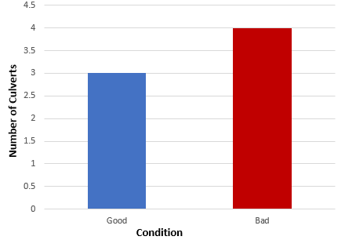

**Figure 3. Inventory condition chart**

Our first objective of obtaining a drainage inventory of the study area [Ayeduase community] was achieved and some analysis and graphs were made to make certain inferences from them. The following were some of the analyses made: Based on the physical conditions of the culverts in the area, the data shows that 4/7 (57%) of the culverts are in bad condition while 3/7 (43%) are in good condition. Those in good condition require maintenance in terms of desilting and clearing for easy passage of water. Most of those in bad condition need replacement and maintenance. This is because they do not have the necessary reinforcement to keep up draining surface runoff. Based on the physical state of the culverts, shows there is no proper reinforcement, and that has led to it being broken and even erosion has made it seem to be hanging. The drains along the main roads are in good condition and are not silted, this is partially because the main roads are tarred which prevents sand from accumulating in them. Some drains in the study area were found to have been constructed by residents instead of experts or authorities. Those kinds of drains are not to standard, hence lacking the needed capacity to convey runoff to destinations. The condition of the culverts will get worse with time since no measures are drafted to properly maintain them.

**Drainage System Map**

A drainage system map of the study area was one of the two specific objectives of this project. To realize this objective of producing a map of the drainage system of the study area, several activities were done to collect data, among these activities were drone flight which produced aerial images and coordinating ground control points. After all required data (aerial photographs, ground control data) had been acquired, they were subjected to different methods and processes including processing aerial photographs in Agisoft to obtain another set of data such as orthophoto mosaic, DEM, and DTM and proceeding to ArcGIS for further work such as georeferencing, digitizing, and other analysis. These different methods and processes were employed individually and generated some results which were coordinated to finally produce a map showing the drainage system of the study area. In this section, the results of all these activities that helped to realize our objectives are given, described in detail, and accompanied by tables and figures for discussion.

**Aerial photographs**

Aerial photographs, one of the core elements of this project were obtained from the study area spanning about 98 acres, and a standard DJI drone was used in capturing the photos. The drone was flown at two different altitudes i.e., approximately 80 m and 85 m, this change in altitude was due to some high-rising buildings in some parts of the area whose altitude conflicted with the rules and guidelines of drone piloting, hence the altitude had to be adjusted to prevent altitude problems. Also due to the kind of data needed from the aerial photos and their purpose, the flight plan was made such that all photos were vertically oriented. The photos were also taken with 60% forward overlap and 30% side lap, these laps were introduced in the flight plan to ensure coverage of the entire area and to prevent strips containing blanks. The overlaps were also important for generating an orthophoto mosaic from the photos because in generating an orthophoto mosaic, only the central part of each photo is used since the central part of all vertical photos is an area of the truest reproduction of terrain. After the drone flight, 568 high-resolution photos were generated. Each with 72 dpi (dots per inch) and a photo dimension of 4864 x 3648 pixels. The photos were very sharp enough to show clearly the ground features, especially the drains and culverts in the area which were important features in defining the drainage system.

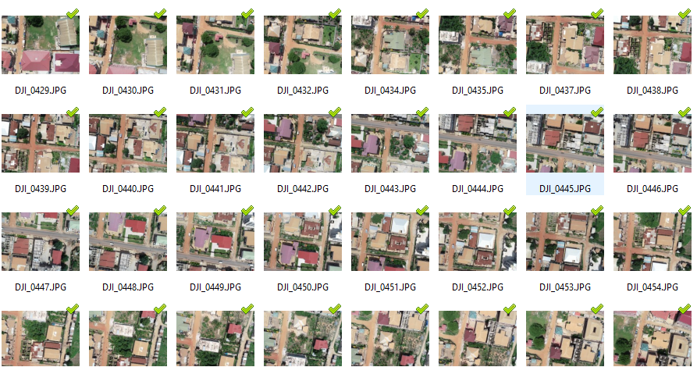

**Figure 4. Sample aerial photos**

**Ground Control**

The provision of ground controls involves getting points whose positions are known in a particular reference system and whose images can be identified on aerial photos. By doing this one can orient the photos to the ground. The accuracy of a finished map can be no better than the ground control upon which it was based (Wolf et all, 1983). In this project, ground control points were established after drone coverage of the area and photos were processed and an orthophoto mosaic was generated: this was because markers were not placed on the ground before flying the drone over the area. Five points were selected after much consideration of requirements for selecting ground control points which are the sharpness of points, favorable location of points, well defined, and so on. After selecting these points and picking these points with GPS instruments, the data was processed to generate the coordinates of the controls. Coordinates were generated in the metric system in the Ghana War Office Datum, thus the Ghana National Grid coordinate system using the Trimble Business Center software.

**Table 2. Coordinates of ground controls**

|  |  |  |
| --- | --- | --- |
| ***POINT*** | ***NORTHING (Meters)*** | ***EASTING (Meter)*** |
| [C1](http://localhost:55682/?Project=fefd457b-4c0d-4bdb-94a9-32a0af901b30&SerialNumber=1281) | 221841.160 | 211944.146 |
| [C3](http://localhost:55682/?Project=fefd457b-4c0d-4bdb-94a9-32a0af901b30&SerialNumber=1291) | 221746.307 | 212541.003 |
| [C4](http://localhost:55682/?Project=fefd457b-4c0d-4bdb-94a9-32a0af901b30&SerialNumber=1294) | 221124.736 | 212537.265 |
| [C5](http://localhost:55682/?Project=fefd457b-4c0d-4bdb-94a9-32a0af901b30&SerialNumber=1297) | 221158.201 | 212091.272 |
| [CB2](http://localhost:55682/?Project=fefd457b-4c0d-4bdb-94a9-32a0af901b30&SerialNumber=1288) | 221604.483 | 212261.232 |

**Orthophotomosaic**

An orthophoto mosaic is a sharper, larger map-quality image with high detail and resolution made by combining many smaller images called orthophotos.

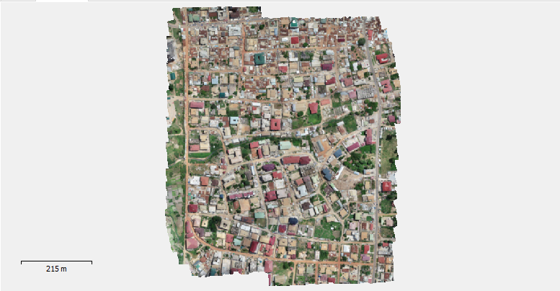

**Figure 5. Orthophoto mosaic map of the study area**

Digitizing drains and numerous other features in the study area was specified as part of the processes required to accomplish our objectives, hence an orthophoto mosaic needed to be derived from the photos to provide a base map to digitize the required features from it. In the Agisoft software, an orthophoto mosaic was generated from the photos by following the workflow.

**Digital Elevation/Terrain Model (DEM / DTM)**

Generating a Digital Elevation Model or Digital Terrain Model was very important in providing us with contours for the entire study area, in Agisoft software, a Digital Elevation Model shows the elevation of the terrain, in addition to natural and human-based objects in the study area (DEM) had to be obtained first before the Digital Terrain Model which shows the elevation of only the terrain in the study area could be obtained through a process called dense cloud classification in Agisoft Photoscan software.

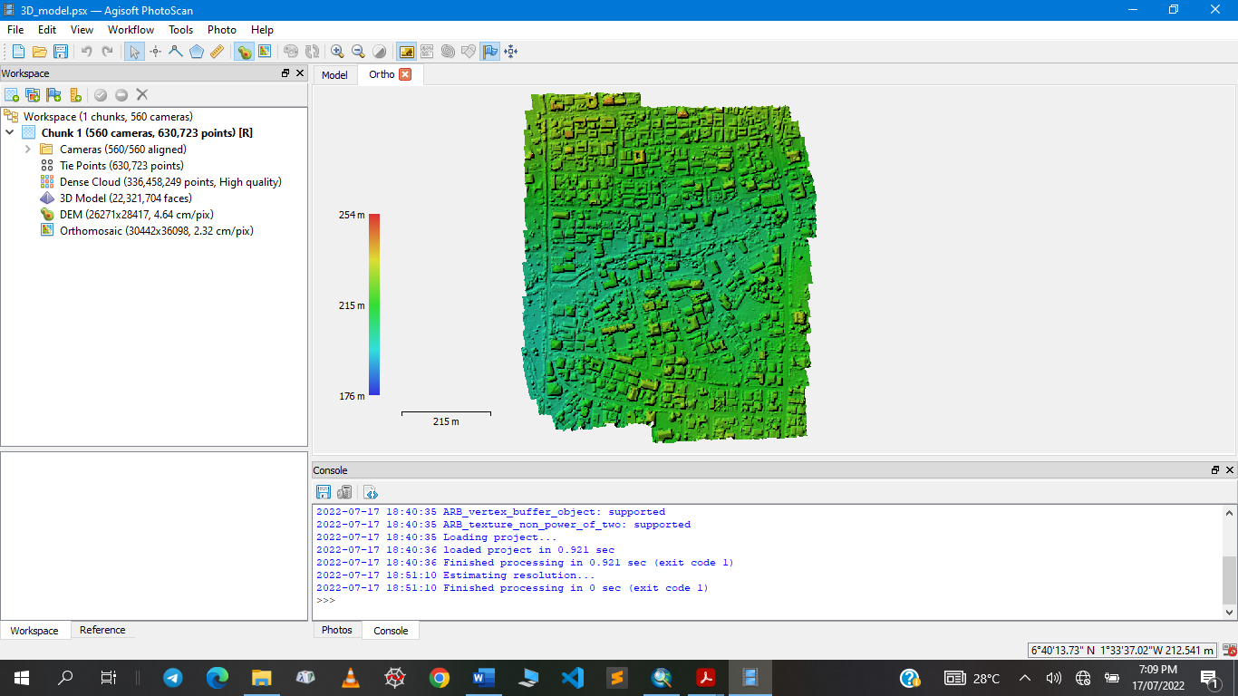

**Figure 6. DEM of study area**

During the classification process, we had to classify the point-dense cloud between ground points and the other features to generate the elevation of only the terrain (DTM). In doing this, certain parameters had to be specified which included Max angle (deg), Max distance (m), and Cell size (m), each of these parameters had to do with both the elevation on the ground as the features above it and the choice of the parameters affected the nature of Digital Terrain Model that would be generated, hence a perfect Digital Terrain Model could not be obtained at the first trial, so several trials were incorporated using different values for the same parameters which generated several Digital Terrain models and the one closest to accurate was selected from it. Below are the results of the different classifications which were undertaken and after the classifications, the “2nd Classification” was selected to generate contours.

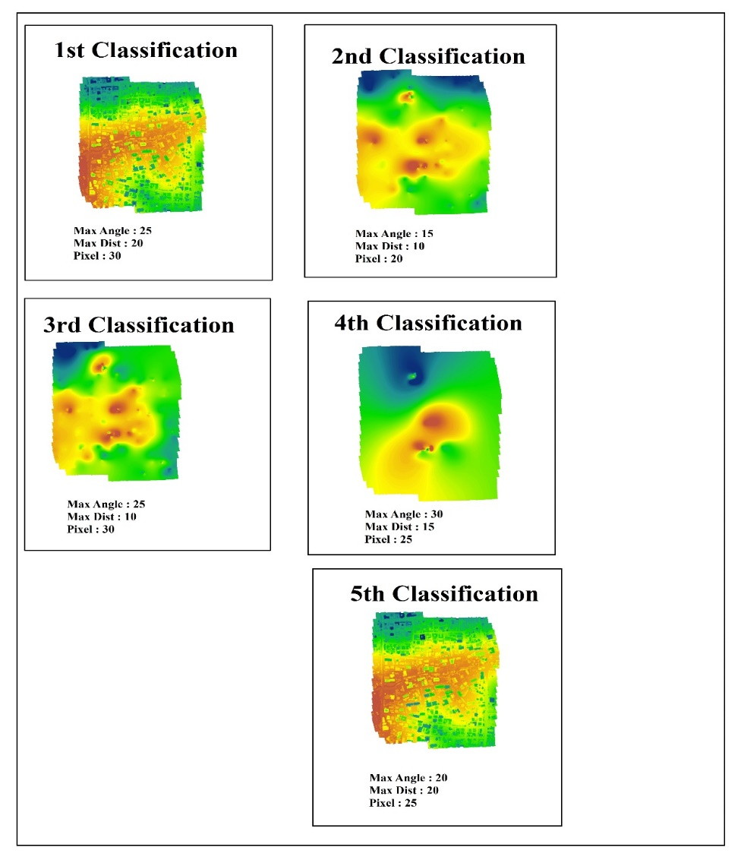

**Figure 7. DTMs generated after different classifications**

**Geodatabase and Maps**

To generate the drainage system map of the study area, several activities led to the creation of a geodatabase with the data obtained. In the ArcMap 10.5 software, the DTM, orthophoto mosaic, and inventory data were used to create a geodatabase concerning the drainage system in the study area. Creating the geodatabase featured several processes like Georeferencing, digitizing, and contour and surface contour generation. Each of the processes generated distinct results for subsequent processes. Georeferencing was done to relate the orthophoto mosaic generated from the drone images to ground coordinates. This was done using the ground control coordinates obtained. Through spatial data analysis tools in the ArcMap environment, the DTM helped generate a contour map.

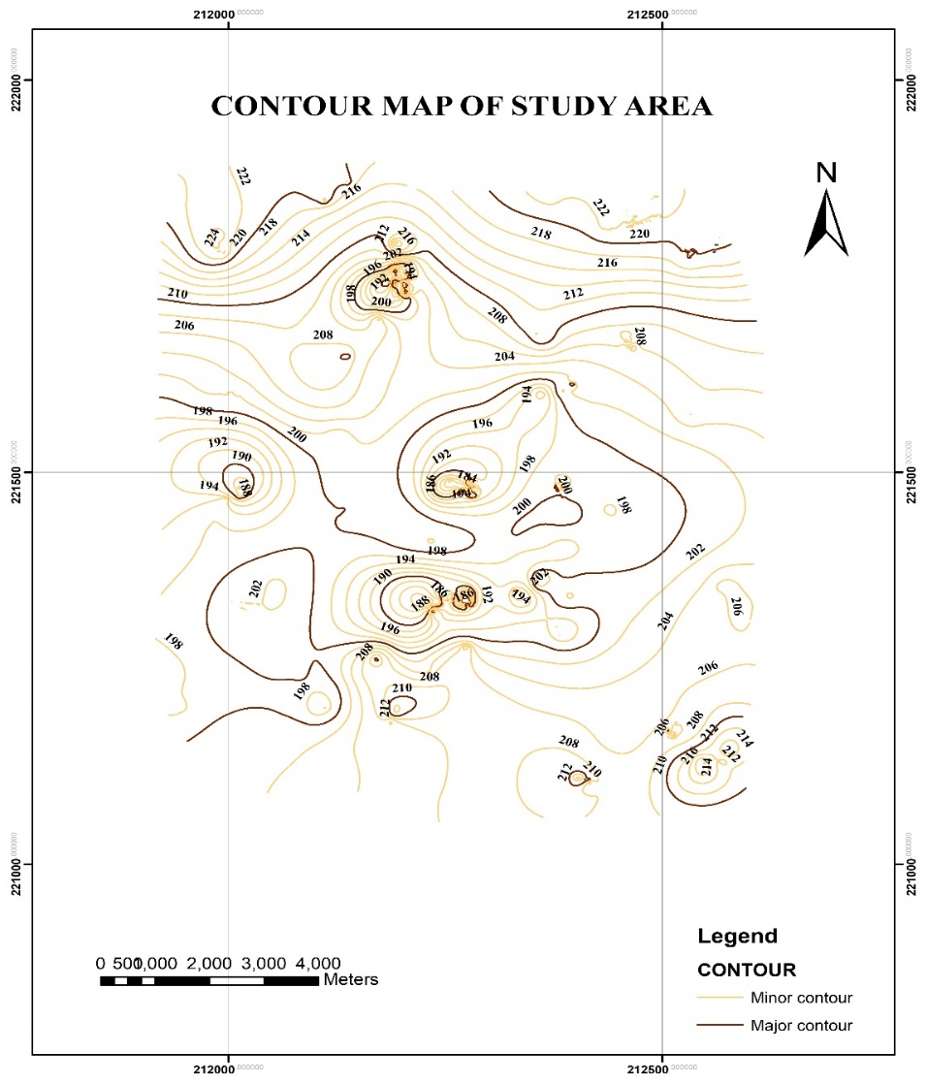

**Figure 8. Contour map of study area**

Several features of interest such as the drains, stream (a natural channel), roads, buildings, etc. were all generated from the orthophoto mosaic in the ArcMap environment. Culverts were also plotted and the respective inventory data was recorded for each of the attributes.

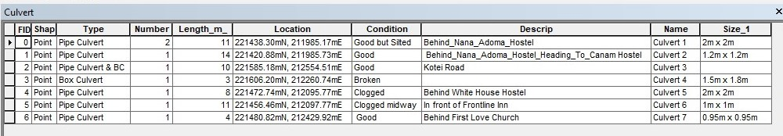

**Figure 9. Attribute data on culverts in ArcMap**

These datasets in turn helped to generate our maps which was the main focus of the second objective. The following are some of the maps plotted from the dataset, each is useful for different purposes as they will be used to do analysis and describe the drainage system as mapped.

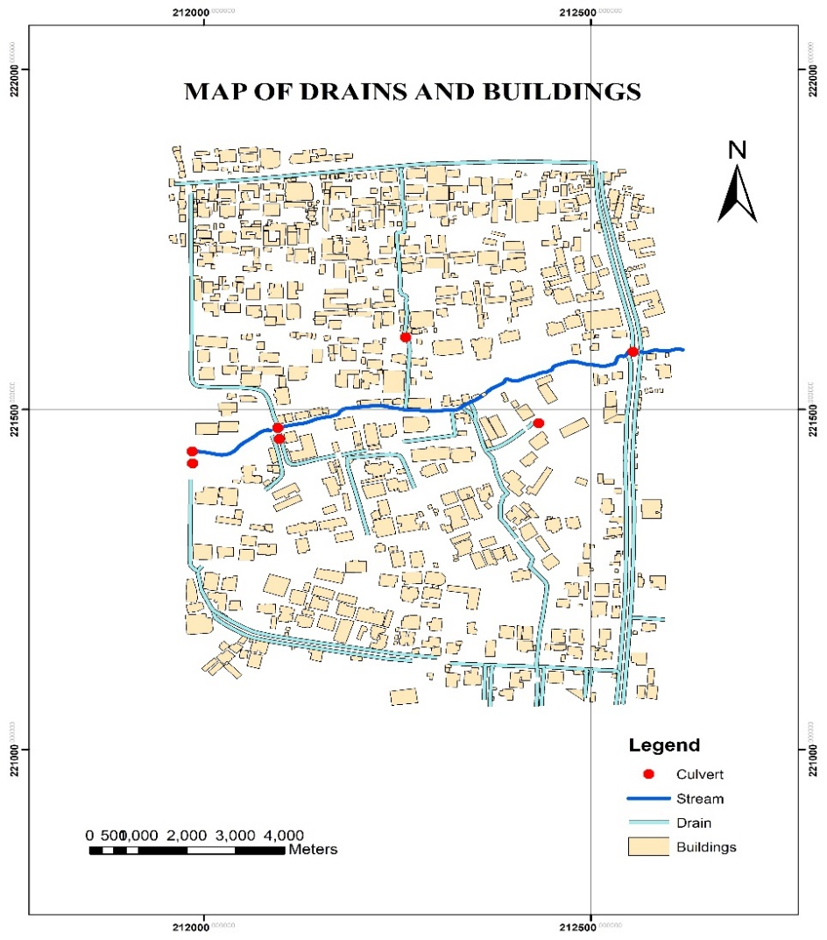

**Figure 10. Map of drains and buildings**

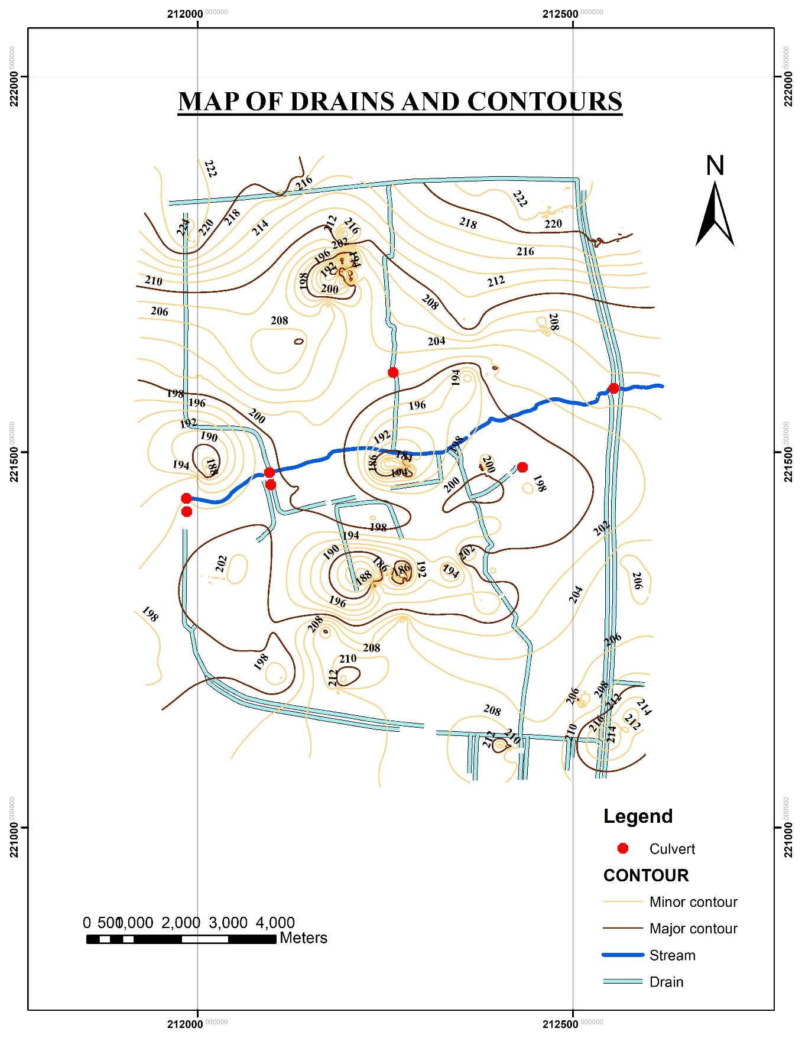

**Figure 11. Map of drains and contours**

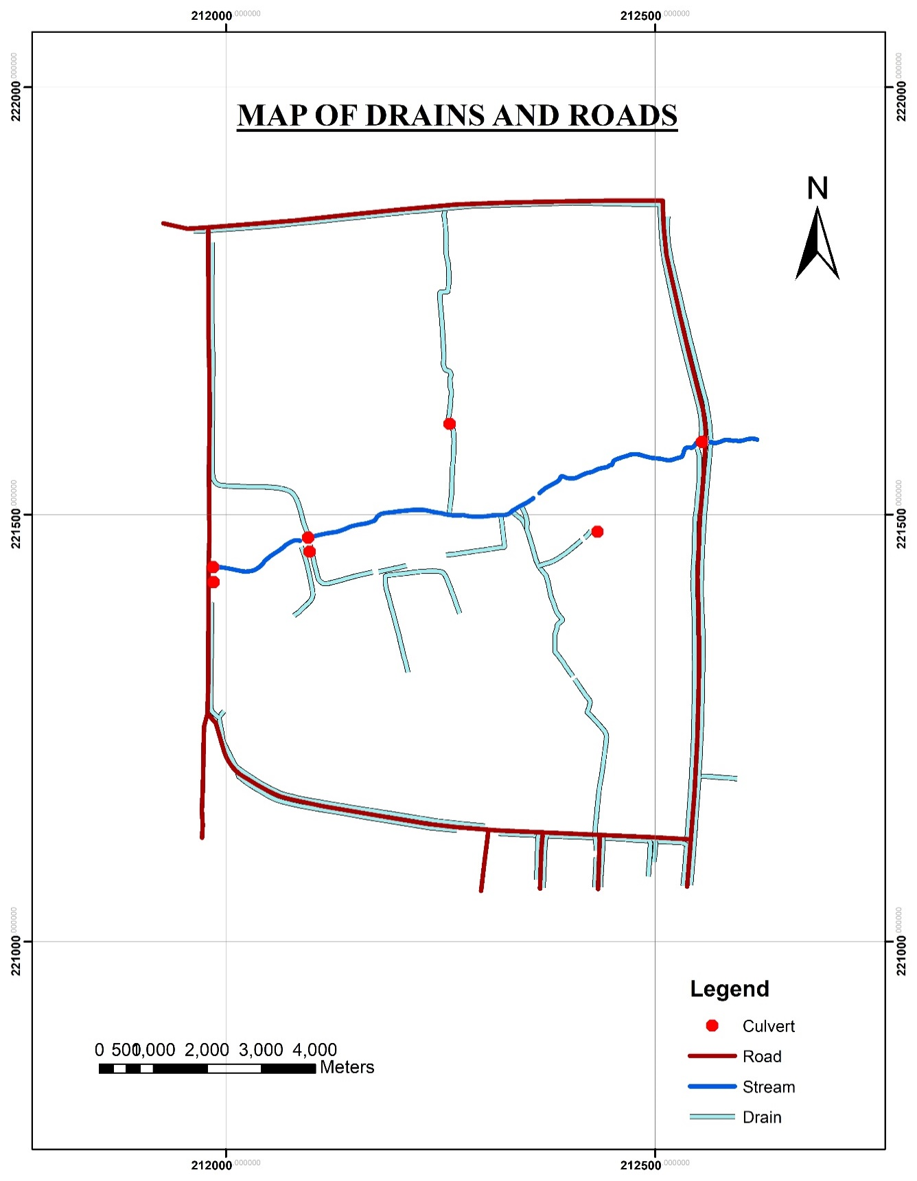

**Figure 12. Map of drains and road**

The drainage system map was finally generated by combining the necessary features in the same ArcMap environment. The drainage system map and all other outputs made in the GIS environment were used for explanation, and analysis and used to inform decisions on the drainage system in the Ayeduase community.

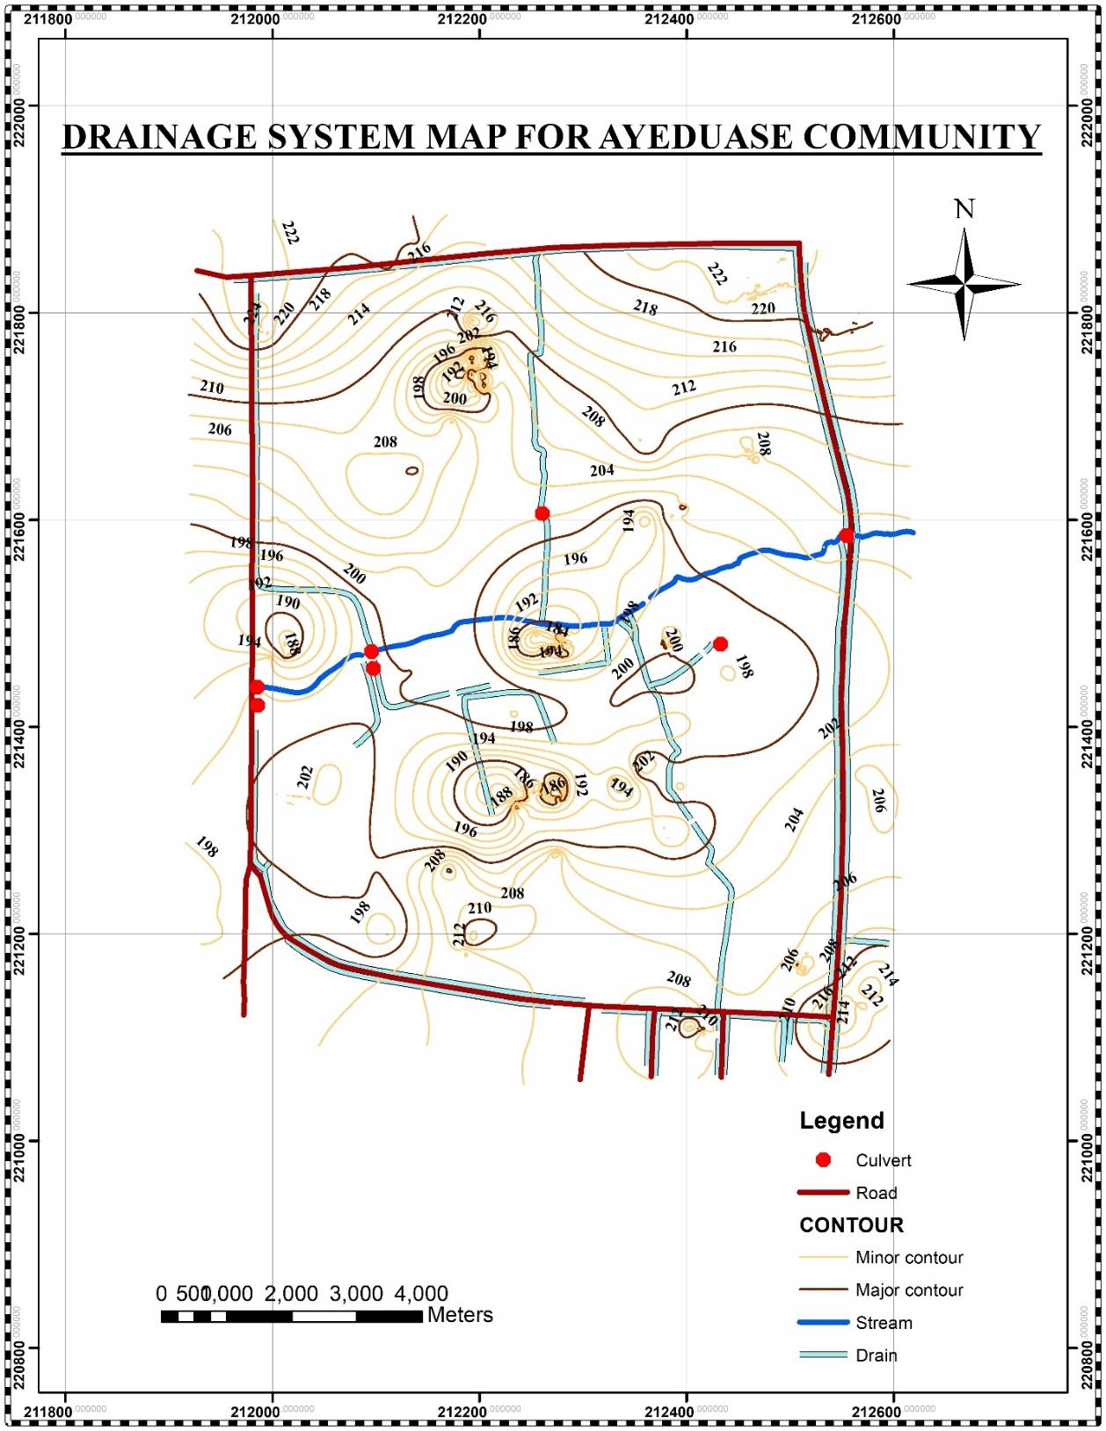

**Figure 13. Drainage system map of the study area**

**Description of Maps**

To prevent clouded layers consequently resulting in a clumsy map, the various layers were combined differently to form different maps that could show very nice relationships among the various components of the drainage system. The different maps made are in Figure 8, Figure 10, Figure 11, Figure 12, and Figure 13. The contour of the community is shown in Figure 8, the contours are plotted in a 2-meter interval with major contours at every 10-meter interval. Gradients in most parts of the map were mostly between 3% - 9% which reveals that most parts of the community have a gentle slope of the gradients were estimated with the cross-section method.

$$m= \frac{Δy}{Δx} x 100\%$$

$$where Δy represents the change in vertical distance$$

$$(Using contour values of contour lines)$$

$$Δx represents the horizontal distance of the cross-section line$$

$$(Using the grid intervals)$$

Figure 10 shows a map that depicts most importantly the drains, culverts, and buildings in the study area. This map helps to identify the relationship between the drains and buildings in the community; the settlement barely has any proper layout. Figure 11 explains the relationship between the nature of the topography of the community and the other components of the drain such as most importantly the open drains and the culverts. Figure 12 is another map showing the relationship between the drainage network and the roads in the community. Figure 13 shows the drainage system of a part of the Ayeduase community that was produced after going through all the processes.

**Findings from the drainage system map**

The different maps were generated to enhance aesthetics and most importantly to produce clear map outputs which show clear relationships in the drainage system for easy explanation. Figure 13 shows the drainage system of the study area as stated in our second objective for this project. After creating the map, it opens room for several revelations including but not limited to the following: Figure 12 shows the relationship between the roads and the study area, and a clear look at the map shows that some of the roadside drains end along the road without proper destination. It could also be noted from the same map (Figure 12) as well as with the drainage inventory that, aside from the extreme edges of the study area which have at least good drains, just a few drains are drains are found in the entire study area. From the contour map (Figure 8), most of the area has gentle topography and slopes downward to stream, and from the drains and contours map (Figure 11) and concerning the inventory data, it can be seen that a single drain lies at the top of the study area and is improperly constructed, it can then be inferred that most of the community depends on natural channels for draining runoff which ends up causing erosion resulting gullies. Some buildings have encroached so close to the stream passing through the community; this goes against the zoning guidelines and planning standards’ 15m riparian buffer zone standard set for minor perennial streams by the Ghana Town and Country Planning Department. Some buildings are walled against the stream, some even built on, and that poses a threat to the water resource and could lead to flooding and the sudden collapse of these buildings as water seeps through the foundations with time, if necessary, actions are not taken in terms of planning. (LUSPA, 2011). Pervious and impervious surfaces affect water infiltration (Booth, 2000). Vegetative land cover has a pervious surface that reduces the rate of stormwater runoff (Kittredege,1973), reduces soil erosion, and most importantly reduces the chances of flooding. However, in Figure 10, the land cover is settlement which is rather a contributor to the adverse effects of the lack of vegetative cover in the community. Finally, the current state of the drainage system after mapping does not possess or disclose the facet of a good and efficient drainage system, hence per the second objective of the project, a drainage system is proposed in the form of a map based on all the analysis made and other technical factors as well. The proposed drainage network for the study area (Ayeduase community) is in the maps as shown below.

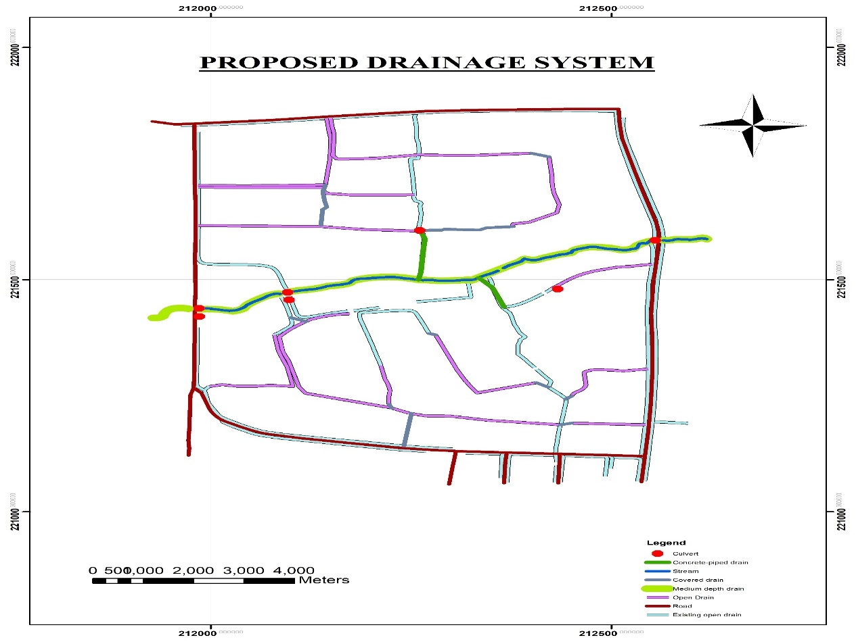

**Figure 14. Proposed drainage network**

Throughout the research, certain challenges confronted us and these challenges are listed below. Drone data requires high-performing computers for fast processing, delaying data processing. Due to the high quality (564 photos) generated from the drone flight, processing the photos in Agisoft required high high-performing computer to hastily process the data we wanted but our laptops were not up to that task, and that delayed data processing. In the course of collecting inventory data, previous data on the physical condition of the most especially the culverts were not obtained, previous data on the physical condition could be used for comparison with the current data, to effectively affirm our assessment of the drainage system’s condition.

**Data Availability Statement**

Some or all data that support the findings of this study are available from the corresponding author upon reasonable request. These include drainage inventory data, aerial photographs, ground controls from the study area, and documents of Ghana’s Survey and Mapping Division’s published coordinates.

**Acknowledgments**

Our utmost gratitude goes to the Almighty God for His care, protection, and strength throughout this project. Special thanks of gratitude to our supervisor Mr. Acquah Boateng Agyemang who made this work possible. We are grateful for the opportunity to experience endless support, guidance, advice, motivation, and contribution throughout this project under his supervision. His immense knowledge helped us complete all stages of the project successfully. We are truly grateful Sir. We would also like to express our sincere gratitude to the panel lecturers especially our very own supervisor Mr. Agyemang, Prof. E. K. Forkuo, Prof. E. M. Osei, and Dr. Asare for their contribution in terms of corrections and advice. We are very grateful to the technicians for their support in completing this project, especially Madam Harriet and Mr. K. Obeng. Finally, we would like to thank our colleagues and friends for their constant source of inspiration and support.

**References**

**1**. Agyemang, A. B., Quaye-Ballard, J. A., Ohemeng, R. Y., Asante, E. Y. (2020). Google Earth As Image Source in Photogrammetric Mapping of KNUST Campus. *Journal Of Science and Technology*, 38(2020) 11 – 20

**2**. Booth, D. (2000). Forest Cover, Impervious-Surface Area, and the Mitigation of Urbanization Impacts in King County, *WA. King Co. Water and Land Resources Division.*

[ Online ] Available at <https://www.digital.lib.Washington.edu/> (Accessed: 1st September, 2022)

**3**. Chapman, P. (2007). *Database Design and Process Modeling for a Drainage Utility GIS*.

City of Austin, Pp. 1-4

**4.** Chen, X. (2011) Seeing Differently: Cartography For Subjective Maps Based On Dynamic Urban Data. *Massachusetts Institute of Technology Library Archives.*

[ Online ] Available at <https://www.dspace.mit.edu/> (Accessed: 16th April, 2022)

**5**. Clifford, A. and Frimpong Boamah, E. (2015). The three-dimensional causes of flooding in Accra. *International Journal of Urban Sustainable Development,*7(1), Pp. 109-129.

[ Online ] Available at <https://www.buffalo.edu/> (Accessed: 6th April, 2022)

**6.**. Essel, B. (2017). The Application of GIS in mapping of flood hazard areas and assessment of risk in Kumasi. *Journal of Energy and Natural Resource Resource Management,* 3(2) 97-103

**7**. ESRI Press Team (2017). *Online mapping, Transforming GIS-and the world.*

[ Online ] Available at <https://www.esri.com/arcgis-blog/> (Accessed: 16th April, 2022 )

**8.** Freeland, R., Allred, B., Eash, N., Martinez, L., De Bonne, W. (2019). Agricultural drainage tile surveying using an unmanned aircraft paired with Real-Time Kinematic – A case study (2019). *Computer and Electronics in Agriculture*. 165(2019).

**9**. Ghanaian Times (2022). *Only State Officials can stop flooding*

[Online] Available at <https://allafrica.com/stories/> (Accessed: 1st April, 2022)

**10**. Kraak M. J. and Ormeling, F. (2013). *Cartography: visualization of spatial data.*

Pearson Education Limited, Great Britain. Pp 215-216

**11.** Kittredge, J. (1973). *Forest Influences: The Effect of Woody Vegetation on Climate, Water, and Soil, With Applications to the Conservation of Water and the Control of Floods and Erosion.* Dover Publications, New York.

[ Online ] Available at <https://www.>digital.lib.cornell.edu/ (Accessed: 1st September, 2022)

**12.**. Leslie, S., Morgan, A., Philippe, G., Jérôme, S. (2016). Drainage System and Detailed Urban Topography: Towards Operational 1D-2D Modelling for Stormwater Management. *Procedia Engineering,* 154(2016) 890 – 897

**13**. Mariam Webster, 2022. Definition of drainage.

[ Online ] Available at <https://www.merriam-webster.com/dictionary>/ (Accessed: 15th April, 2022)

**14**. Muhammad, F. B. (2007). Mapping and monitoring Drainage System of Universiti Teknologi Petronas.

[ Online ] Available at https://utpedia.utp.edu.my/9579/ (Accessed: 10th April, 2022)

**15**. Nick, M. (2021). The different types of surface drainage system.

[ Online ] Available at [https://www.abtdrains.com/drainage systems](https://www.abtdrains.com/drainage%20systems)/ (Accessed: 16th April, 2022)

**16**. Paul Wolf, R., Bon Dewitt, A., and Benjamin Wilkinson, E. 1983. *Elements of Photogrammetry,* 4th Edition, McGraw-Hill Education, USA, Pp. 12-14.

**17**. Seth Thompson (2020). *Drone Mapping in Real Estate Industry, National Land Realty*

[Online] Available at <https://www.alabamarealtors.com/posts/> (Accessed: 19th April, 2022)

**18**. Shawky, M., Moussa, A., Hassan, Q. K., El-Sheimy, N. (2019). Pixel-Based Geometric Assessment of Channel network/Orders Derived from Global Spaceborne Digital Elevation Models. *Remote Sensing, (2019)11(3)*

**19**. Town and Country Planning Department-Land Use and Spatial Planning Act (LUSPA) (2011). *Zoning Guidelines And Planning Standards,* Ministry of Environment Science And Technology,Ghana, Pp. 64 - 65

[Online] Available at <https://www.luspa.gov.gh/>media (Accessed: 1st September, 2022)